INNOVATION IN VILLAGE GOVERNMENT IMPLEMENTATION MANAGEMENT THROUGH E-VILLAGE BUDGETING (EVB) IN BANYUWANGI REGENCY AND RESTORATION OF VILLAGE ASSET ARCHIVES (REST AREA) IN EAST JAVA PROVINCE

Abstract
This study is about innovation in strengthening village administration management through E-Village Budgeting (EVB) in Banyuwangi Regency and Village Asset Archive Restoration (REST AREA) in East Java Province. The E-Village Budgeting (EVB) innovation is an online-based village financial management system that includes planning, financial administration, and financial accountability or reporting for villages. The Village Asset Archive Restoration (REST AREA) innovation is an innovation program for preservation, including the handling, repair, and rescue of village asset archives and information. These two innovations have given rise to various strategies that offer conveniences in the administration of village government activities in the areas of financial management and village asset archiving. This study uses a qualitative research approach. Data collection was conducted using the literature review technique. A literature review is a systematic examination of critical scientific literature in analyzing, evaluating, and synthesizing research findings, theories, and practices. A literature review provides an overview of developments in a particular topic. The result of the E-Village Budgeting (EVB) innovation is the creation of a website-based village financial management application to facilitate village governments in an orderly, transparent, and accountable manner in planning, budgeting, administration, accountability, and reporting of village finances in the Banyuwangi Regency ( ). The result of the Village Asset Archive Restoration (REST AREA) innovation is an improvement in the delivery of public services by village governments in East Java Province through an innovation program for the preservation and rescue of high-value village asset archives and the guarantee of protection of the civil rights of the people from the possibility of loss and damage.
Keywords: Innovation, Management, Finance, Archives, Village

I. INTRODUCTION
This study is about innovation in strengthening village administration management through E-Village Budgeting (EVB) as a village financial management system in Banyuwangi Regency and Village Asset Archive Restoration (REST AREA) as a program for the preservation and archiving of village assets and the guarantee of civil rights for communities in East Java Province. Various regions in Indonesia are formed from indigenous communities and small social groups that come together to form a community called a village. The development of a country can be monitored by how developed its rural areas are. Equitable economic development in Indonesia has long been a key issue and problem that the government must immediately resolve. This has prompted the government to issue various policies to achieve equitable development, namely by providing direct financial assistance to villages and granting each region the authority to manage its own affairs without waiting for instructions from the central government, commonly referred to as regional autonomy. ( . Since the enactment of Law Number 6 of 2014 concerning Villages, there has been an indirect impact on the increase in village revenue sources. The large budget managed by the village must also be accompanied by better management, because these budgets must be accounted for properly, correctly, and transparently. However, even before the enactment of Law No. 6 of 2014, the village government had been managing the Village Fund Allocation (ADD), which was not very large, but various problems were still found due to the complexity of village financial management, the limited resources of the village government apparatus, and the demands for transparency and accountability in village financial management.( Banyuwangi Regency , 2019) .
Problems in the Banyuwangi Regency include the lack of understanding among village government officials in managing village administration and information technology, resulting in low validity due to manual systems. The planning, administration, evaluation, and reporting processes in the Regional Revenue and Expenditure Budget (APBD) are carried out manually and inaccurately, resulting in a lack of accountability, such as budget discrepancies between planning and realization in reporting. Inadequate village financial management has resulted in suboptimal policies for optimizing village government performance. In addition, the implementation of program activities is time-consuming, labor-intensive, and costly, often resulting in delays in bookkeeping. Law No. 23 of 2014 on Regional Government states that in order to improve the performance of regional government administration, regional governments can implement innovations. Innovation is any form of renewal in the administration of regional government. Innovation is needed by regional governments as a strategic step to improve the administration of good and clean regional government( Pratiwi, 2016) (Satia Utama & Zahari, 2020) . One form of innovation in village fund financial management is the incorporation of technological sophistication into the operational activities of E-Village Budgeting (EVB). The EVB innovation is a website-based or online village financial management system that facilitates village governments in compiling plans, managing finances, and providing accountability or financial reporting in an orderly, transparent, and accountable manner.
The President of the Republic of Indonesia, through the Nine Programs for Change for Indonesia (Nawacita) point 2, wants to build a clean, effective, democratic, and trustworthy system of government. To achieve this goal, a legitimate and standardized administrative system is needed. Meanwhile, in the preamble to Law No. 43 of 2009 on Archives, the government affirms its commitment to guaranteeing the civil rights of the people through the implementation of archiving. In village administrations, information about the civil rights of the community is recorded and stored in village/sub-district asset archives, commonly referred to as letter C. The problems found in East Java Province include 8,501 villages/subdistricts storing approximately 500 Letter C asset archives per village, or the equivalent of approximately 4,250,500 archives that have deteriorated and suffered physical damage. Repairing these archives requires a large amount of money, approximately Rp. 10,000 per archive. The total estimated cost is around 42.5 billion. With this estimate, each district/city needs a budget of 1.2 billion. Materials for repairing or restoring archives, such as Japanese tissue paper, can only be obtained through import. The potential for natural disasters in East Java is also very high, which has a direct impact on the damage to village asset archives. In addition, there are many complaints from local governments regarding the handling of village asset archives. Many village C-letter archives are not suitable for direct access by the community. The Village Community Institution (LKD) has also not been felt to be present or beneficial in the process of restoring high-value archives in the region. The restoration of high-value archives in villages has not been addressed, resulting in many village asset archives becoming fragile, torn, and even difficult to recognize. To overcome this problem, the handling of village/sub-district asset archives has been initiated through the Preservation Innovation Program, also known as the Village Asset Archive Restoration (REST AREA). The REST AREA innovation is a preservation innovation program that includes the handling, repair, and rescue of village asset archives and information. It is hoped that this innovation will improve the preservation and rescue of high-value village asset archives and guarantee the protection of the civil rights of the people from the possibility of loss and damage.( East Java Province , 2019) .
The objective of this study is to describe the efforts made by local governments to strengthen village administration management in Banyuwangi Regency and East Java Province. This research focuses on innovations in strengthening village fund management by incorporating technological sophistication into financial management operations through the E-Village Budgeting (EVB) innovation and strengthening innovation programs for preservation, including the handling, repair, and rescue of village asset archives and information through the Village Asset Archive Restoration (REST AREA) innovation. So far, there have been quite a number of studies reviewing the improvement of village government services, such as the study conducted by( Anggraeni et al., 2020) on E-Government-Based Public Service Innovation: A Case Study of the Sapa Cetar Application. The study describes a new service application system called Sapa Cetar. This is an online-based application to facilitate community services in managing various population administration matters and improving village-owned enterprises. Another study conducted by (Setiawan, 2015) discusses the decentralization of static archive management in the era of regional autonomy from 1999 to 2015 at the Regional Archives and Library Office of Pati Regency. The study explains that the management of static archives in Pati Regency had already been implemented before 1999. At that time, some of the archives were handed over to the provincial archives institution. After 1999, the management of static archives was carried out independently. Previously, the management of static archives was based on Law No. 7 of 1971 concerning Basic Provisions on Archives and other regional regulations. At that time, the acquisition of inactive archives from regional agencies had been carried out and several archives had been reproduced for service. After the emergence of Law No. 43 of 2009 concerning Archives, static archive management was carried out electronically, acquisition was accompanied by an Archive List, and there was an archive tour service. However, several innovation studies, such as the use of the Sapa Cetar Application, emphasized innovation in population administration services and the improvement of village-owned enterprises (Bumdes). Then, the management of static archives based on Law No. 43 of 2009 concerning Archives was carried out not by the village government but by the Regency/City Archives Institution. Meanwhile, innovation emphasized the management of village funds based on electronic technology and village asset archives. This research is also considered important and relevant because it examines the conditions of the village administration strengthening system, particularly in the areas of village financial management in Banyuwangi District and village asset archive management in East Java Province.

II. METHOD
This study uses a qualitative research approach. Data collection was carried out using the literature review technique. According to Click or tap here to enter text. A literature review is a systematic examination of critical scientific literature in analyzing, evaluating, and synthesizing research findings, theories, and practices. A literature review provides an overview of developments in a particular topic. The compilation of scientific literature involves several stages of the process, including finding relevant literature, evaluating literature review sources, identifying themes, identifying gaps between theory and field conditions, if any, creating an outline structure, and compiling a literature review (Cahyono et al., 2019) . This research was conducted by presenting innovations in the personnel information system in an effort to strengthen village administration management through E-Village Budgeting (EVB) in Banyuwangi Regency and Village Asset Archive Restoration (REST AREA) in East Java Province. This research was conducted systematically. Data collection was also carried out by searching various sources, which were then processed and described in narrative form according to data requirements. The data used came from reports, journals, books, scientific articles, and literature reviews containing the concepts being studied.
III. RESULTS AND DISCUSSION
- Overview
System Information Technology (SIT) is an important asset for the development of an organization. The application of SIT can also be used as a tool for planning, control, and decision-making. For public organizations, the use of SIT can help make public services more transparent and accountable. Therefore, SIT cannot be separated from the activities of an organization, especially in the public sector, in order to be more transparent so that it will be easier for the community to monitor. Banyuwangi is one of the local governments that has been aggressively innovating in the public sector to improve service performance and increase regional competitiveness. The Banyuwangi Regional Government has made SIT a main pillar in supporting public services in Banyuwangi, from the regional government to the village government. The first step to realize this was to collaborate with PT. Telkom to install 1,000 free Wi-Fi points throughout the Banyuwangi Regency. The public service innovations that have been adopted as programs by the Banyuwangi Government are the Smart Village Program, Transparency in Regional Financial Management, the Government Performance Accountability System, and E-village Budgeting (EVB). According to Law No. 6 of 2014 on Villages, villages are required to use information systems. The obligation to use an information system is based on the large amount of funds allocated by the Central Government to the Village Government, and each village is required to prepare and manage its budget plan in a transparent and accountable manner, including village financial reports. The Banyuwangi Government has implemented the EVB system or online financial system. The purpose of implementing the EVB system is to achieve transparency in budgeting, monitor development down to the village level, and synergize finance and development between the village and regency levels. In addition, the implementation of EVB also aims to provide an umbrella for village officials so that the use and allocation of village funds becomes more effective and in accordance with regulations. The Banyuwangi Regency Government's EVB program received the Top 40 award in the Public Service Innovation Competition (Sinovik) from the Ministry of State Apparatus Empowerment and Bureaucratic Reform (Menpan-RB) in 2017. (Source: banyuwangikab.go.id).
Other agencies, whether government or private organizations or even individuals, always have something to do with archives. Archives play an important role in the process of presenting information, including for making policies and decisions. As the volume of archives increases throughout the village administration's activities, the archives will continue to grow. Archival management needs to be carried out, with the aim of achieving orderly archives, ease of retrieval, and preservation of archives that contain important information. The East Java Library and Archives Office has created the Village Asset Archive Restoration (REST AREA) program. This innovation involves partnerships with district/city archival institutions, sub-districts, village administrations, the East Java Association of Archivists, and the Forum of the Archive-Aware Community (FKMSA) from 25 universities in East Java. The REST AREA innovation includes socialization of orderly archiving, training in the preservation of asset archives, and archival restoration internship services. Good and accountable archiving practices will ensure orderly administration. The people must have the right to receive services and must be aware of their civil rights. The rights of the people in the context of village/sub-district administration are the rights to obtain information about their assets recorded in letter C archives stored by the village government. In public services, the village government is required to maintain and preserve village asset archives as a fundamental part of guaranteeing the civil rights of the people in their area. Information on civil rights is recorded and stored in letter C archives.
- E-Village Budgeting (EVB) Innovation and Village Asset Archive Restoration (REST AREA)
The E-Village Budgeting (EVB) innovation is a village budgeting system that is integrated into an online network. The EVB system consists of three parts, namely planning, governance, and evaluation. Planning involves the preparation of village budget plans in accordance with the village's authority, which refers to the district development plan. Governance is the administration of village government based on applicable principles. Evaluation is intended as monitoring of village administration regarding planning in village development. The implementation of the EVB system has several objectives. First, to achieve transparency in budgeting and monitor development in all corners of the village. Second, to synergize finance and development between the district and village levels so as to create harmony. Third, to provide protection to village officials so that the use of the budget is more effective and in accordance with the rules. The mechanism for using the EVB application includes that users must first be registered, and each user will be grouped into certain groups that have different access rights depending on their authority. User registration and access rights are managed by the application administrator as a whole. Then, contact the application administrator to obtain a login name (user name) and password to use the application, which has been determined by the administrator. Web browsers that can be used include MS Internet Explorer, Netscape, or Mozilla. If the address entered is correct and all the above standards are met, a screen will appear to log into the application, as shown in Figure 3.1.


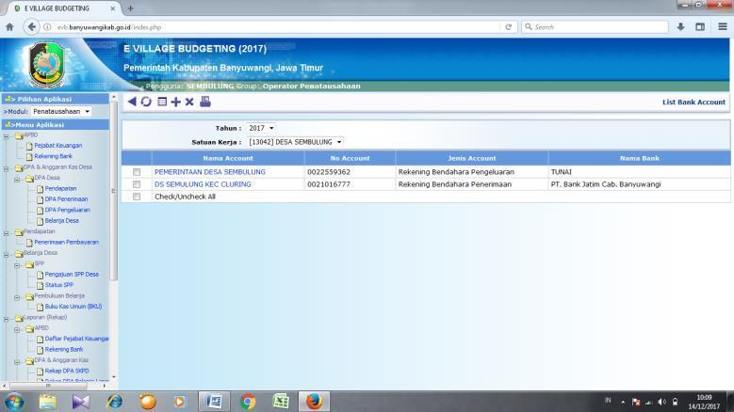

Figure 3.1. E-Village Budgeting Website for Banyuwangi Regency (evb.banyuwangikab.go.id)
To log in to the application, enter your Username and Password, then click the login button. If the username and password you entered are correct, you will be directed to the EVB application's initial screen.
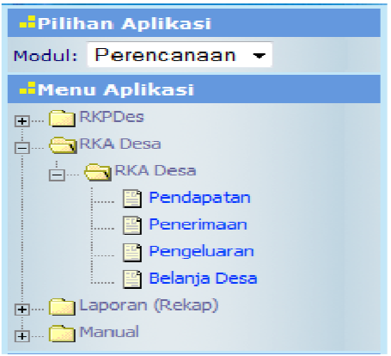
Figure 3.2. The initial screen in EVB when the Planning Stage is selected
The development of the E-Village Budgeting application has certainly had a positive impact on village financial management and evaluation, enabling village financial administration to be carried out in accordance with the cycle and principles of village budget management.
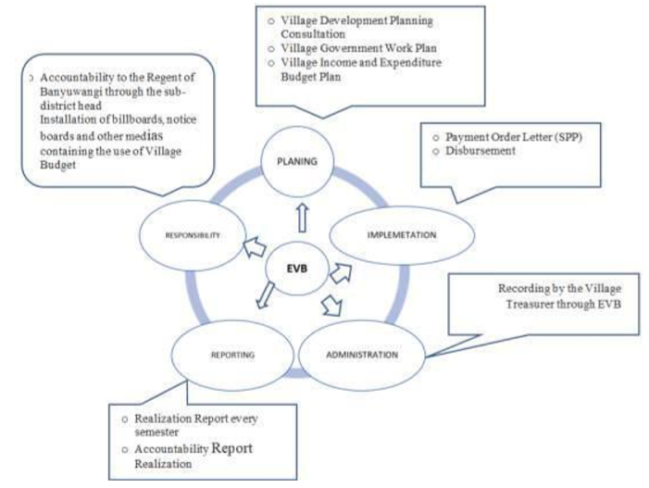
Figure 3.3. Village Financial Management Cycle in Banyuwangi According to (Source: Anwar, 2019)
The output achievements that can be felt with the development of the EVB application in this innovation are: First, the EVB application system that can be accessed by all villages at the website evb.banyuwangikab.go.id. Second, the DD/ADD consultation clinic as a place for consultation and assistance. Third, training for village officials on planning, administration, and reporting of village financial management. Fourth, follow-up efforts on Regent Regulation No. 15 of 2015 on Guidelines for Village Financial Management in Banyuwangi Regency as the legal basis for strengthening EVB development. Fifth, a module as a guide to facilitate the use of the E-Village Budgeting application.
The Village Asset Archive Restoration Innovation (REST AREA) is an innovative preservation program that includes the handling, repair, and rescue of village asset archives and information. Prior to this innovation, archive restoration was only carried out on archives stored at the Provincial Regional Archives Agency (LKD). Archive restoration in villages was not carried out. As a result, many village asset archives were fragile, torn, and some archives were even difficult to recognize. Therefore, the government handled village asset archives through the Preservation Innovation Program or Village Asset Archive Restoration, which was then abbreviated as "REST AREA" in 2017. The main target of this innovation is the village administration in East Java Province, which has 8,501 villages/subdistricts. The REST AREA innovation will be effective if it collaborates with many stakeholders. This will improve public service delivery at the village/subdistrict level. The most successful outputs of the REST AREA innovation can be seen in Table 3.1 Success of the Use of the REST AREA Innovation as follows.
Table 3.1 Success of the Use of the REST AREA Innovation
Category | Number
 | 2014 | 2015 | 2016 | 2017 | 2018
Trained Human Resources | 0 | 0 | 0 | 0 | 32
Implementing LKD | 0 | 0 | 5 | 5 | 5
Village Asset Archives | 0 | 0 | 0 | 7,117 | 7,450
Source: East Java Provincial Regional Innovation Index Report 2018
The success of the REST AREA Innovation output is measured by calculating the number of local governments or local archival institutions (LKD) in districts/cities that have followed up, continued, and replicated the REST AREA Innovation, as well as the number of village asset archives in the form of village C letters that have been successfully restored and saved from damage.
- Benefits of Implementing the Innovation
The main benefits felt from the implementation of the E-Village Budgeting (EVB) application by both village and district governments include: First, the ease of village financial planning and administration using the application system. Based on the evaluation results, by the end of 2015, all (189) villages had been able to absorb the ADD and DD financial assistance budgets, as detailed in Table 3.2.
Table 3.2. Percentage of Budget Absorption in Banyuwangi District
No. | Village Finance | Number of Villages | Percentage
ADD Funds
1. | Phase I | 189 | 100
2. | Phase II | 189 | 100
3. | Phase III | 186 | 99.77%
DD Funds
1. | Phase I | 189 | 100
2. | Phase II | 189 | 100%
3. | Phase III | 186 | 99.77%
Source: Source: Banyuwangi Regency Regional Innovation Index Report 2015
Second, the efficiency and effectiveness of village financial management can be carried out in an orderly, transparent, and accountable manner, and in synergy with the processes of planning, budgeting, administration, and reporting of village finances. Third, the planning process from the data entry of the village development planning deliberations and the results of the village deliberations as outlined in the RKPDes (Village Development Work Plan) to the APBDes (Village Budget), the output produced can be seen directly. Fourth, ease of internal control processes in village governments and higher-level government agencies related to the utilization of the Village Budget (APBDes), financial assistance funds from the regency government and from the central government. Fifth, ease in presenting village financial data and in formulating policies related to the utilization of Village Funds, Village Fund Allocations and other financial assistance funds.
Notable changes after the implementation of the EVB application include: First, the pattern of program planning has become more focused in line with previous planning results and the aspirations of the village community. Second, village financial management is carried out using a system that minimizes errors in recording or administering village finances. Third, the realization of efficiency and effectiveness in village financial management because it is carried out systematically. Fourth, the knowledge of village administrative staff in village financial management has increased. Fifth, the disbursement of village budgets and other financial assistance in the form of village fund allocations can be controlled appropriately, effectively, and efficiently. Fifth, it is easier to carry out internal control by the village, sub-district, and district.
The Village Asset Archive Restoration (REST AREA) innovation has provided many benefits to stakeholders, including: First, the community feels more secure about the safety of evidence of land ownership rights or assets and provides peace of mind to residents that their ownership evidence is protected from damage. Second, it helps village administrations secure and save village asset archives from possible damage due to disasters or aging, and encourages village officials to improve their performance in providing services to the community, especially those related to civil rights. Third, it opens up the mindset of district/city archival institutions in carrying out their duties and functions. Fourth, it strengthens the Forum for the Archive-Aware Community in contributing to community service in village administration. Fifth, it strengthens the existence of LKD.
IV. CONCLUSION
The government has issued various policies to achieve equitable development, namely by providing direct financial assistance to villages and granting authority to each region to manage its own affairs. This began with the issue of the understanding of village government officials in the Banyuwangi Regency regarding village financial management, which was not yet optimal, resulting in low validity due to the continued use of manual systems. In addition, it was found that in East Java Province, there were many archives that had deteriorated and suffered physical damage. Repairing these archives would require significant costs. The potential for natural disasters in East Java is also very high, which has a direct impact on the damage to village asset archives. Many of the village C-letter archives are not suitable for direct access by the community. Therefore, efforts were made to strengthen village administration management through E-Village Budgeting (EVB) in Banyuwangi Regency and Village Asset Archive Restoration (REST AREA) in East Java Province. The E-Village Budgeting (EVB) innovation is an online-based village financial management system that includes planning, financial administration, and accountability or financial reporting for villages. The result of the E-Village Budgeting (EVB) innovation is the creation of a website-based village financial management application to facilitate village governments in planning, budgeting, financial administration, accountability, and financial reporting in an orderly, transparent, and accountable manner in the Banyuwangi Regency. Meanwhile, the Village Asset Archive Restoration (REST AREA) innovation is a preservation innovation program that includes the handling, repair, and rescue of village asset archives and information. The results of the Village Asset Archive Restoration (REST AREA) innovation are improvements in the delivery of public services by village governments in East Java Province through an innovation program for the preservation and rescue of high-value village asset archives, as well as guarantees for the protection of citizens' civil rights from the possibility of loss or damage.
V. ACKNOWLEDGEMENTS
The researchers would like to express their deepest gratitude to those who contributed to the writing of this journal, so that the research could be completed to the best of their ability.
VI. REFERENCES
Al Amin, M. N. F., Suaedi, F., & Setijaningrum, E. (2020). Evaluation of E-Village Budgeting Program in Banyuwangi District,456 (Bicmst), 7–10. https://doi.org/10.2991/assehr.k.201021.002
Anggraeni, N & Purnamasari, H. (2022). E-Government-Based Public Service Innovation: A Case Study of the Sapa Cetar Application. Nusantara Journal of Social Sciences, Vol 9(6), pp. 2009-2014. Retrieved from http://jurnal.um-tapsel.ac.id/index.php/nusantara/index
Anwar, A., Pamungkas, T. S., Wicaksono, G., & ... (2019). Innovation of Local Village Budgeting Management: The Case Study of Banyuwangi Regency Electronic Village Budgeting. 2nd INTERNATIONAL SEMINAR SERIES ON REGIONAL DYNAMIC (ISSRD) 2018, (6), 140– 149. Retrieved from https://jurnal.unej.ac.id/index.php/ISSRD/article/view/13755
Cahyono, E. A., Sutomo, & Harsono, A. (2019). Literature Review: Writing and Compilation Guidelines. Nursing Journal, 12.
Efron, S. E., & Ravid, R. (2018). Writing the Literature Review: A Practical Guide. Guilford Publications.
Harisca, R., Huda, A., & Slamet, L. (2017). Development of a Web-Based Personnel Information System at MAN 1 Padang. Voteteknika (Vocational Electronics and Informatics), 5 (2). https://doi.org/10.24036/voteteknika.v5i2.8505
H. Susiani, “Enforcement of Local Regulations (A Study of Street Vendor Control in Bandar Lampung),” Fiat Justisia J. Law, vol. 10, no. 1, pp. 101–124, 2016.
Iswahyudi, M., Rosidi, R., & Baridwan, Z. (2019). Attitude of Village Government To Use E-Village Budgeting (Evb) in Compilation of Add: An Integration of Decomposed Theory Planned Behavior and Risk. International Journal of Social and Local Economic Governance, 5 (1), 49–56. https://doi.org/10.21776/ub.ijleg.2019.005.01.6
Iswahyudi, M. (2017). Determinants of Village Government Attitudes in Using the E-village Budgeting System. Journal of Public Administration (JIAP), Vol 3(2), 90-98.
Regional Innovation Index Report for Banyuwangi Regency. Pages 1-7.
Regional Innovation Index Report for . Pages 1-9.
Pratiwi, Ratih Nur. 2016. Village Financial Management Through Electronic Village Budgeting Innovation (A Study of the Community Empowerment and Village Government Agency of Banyuwangi Regency). Journal of Public Administration Vol. 2, No. 3, pp. 123-130
Rizaldy, I., Rusdiana, E., & Ahmad, G. A. (2020). Village Financial Management in Reducing Crime. JURNAL HUKUM Volume 7 Number 1, 7.
Satia Utama, A. A. G., & Zahari, A. R. (2020). E-Village Budgeting: Effectiveness of Fraud Prevention in Village Financial Management in Banyuwangi Regency. Journal of Accounting and Auditing, 16 (1), 54–75. https://doi.org/10.14710/jaa.16.1.54-75
Setiawan, M. V. (2015). Decentralization of Static Archive Management in the Era of Regional Autonomy 1999-2015 at the Regional Archives and Library Office of Pati Regency. Journal of Library https://ejournal3.undip.ac.id/index.php/jip/article/view/9735%0Ahttps://ejournal3.undip.ac.id/index.php/jip/article/viewFile/9735/9456
Suhendra, A. (2021). Electronic Licensing as a Solution to Licensing Process Problems in Siak and Karo District. International Journal of Regional Innovation, 1(3), 1-7. https://doi.org/10.52000/ijori.v1i3.19f
Suhendra, A., Radianto, I., Setia, A. (2019) Pusat, J., Perdesaan, I., Sosial, I., … Kebijakan, I. (n.d.). Social Interventions Of Regional Governments In Building Rural Innovation In Hulu Sungai Selatan Regency , South Kalimantan Province.
Law of the Republic of Indonesia Number 23 of 2014 concerning Regional Government
Law Number 6 of 2014 concerning Villages
Law No. 43 of 2009 on Archives
Law No. 7 of 1971 on Basic Provisions on Archives

